Pyber – Power of plots

Observation 1

The temperature in the hemisphere which is currently in summer (southern) has more warmer temperature observations. In addition is it interesting to see the wide variance of temps in the northern hemisphere which is currently in summer

Observation 2

Cloudiness, humidity and wind speed to me do not seem to matter based on your latitude as we have a fairly even representation across those locations.

Observation 3

The scale for cloudiness produces bands which indicates the measurement scale is not that granular.

Plots

1. Temp v lat

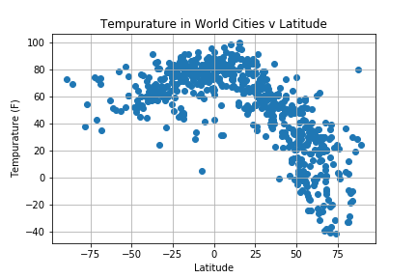

1. Humidity v lat

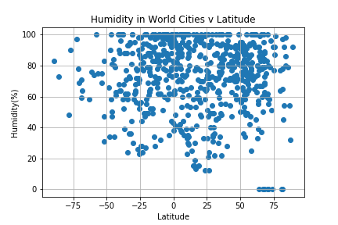

1. Cloudiness v lat

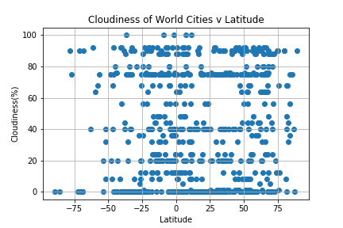

1. Wind speed v lat

